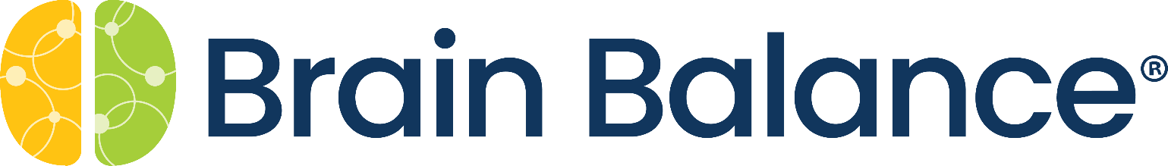

For Immediate Release
Media Contact:
Sara Wacker, APR
Bloom Public Relations
(858) 945-1104
Sara@BloomPRSanDiego.com
(Not for publication)

Brain Balance San Diego Presents New Year
Workshops, Assessments & Activities

San Diego, Calif. (Jan. 12, 2023) – Brain Balance, a leading drug-free brain training program, designed to help adults and kids improve focus, behavior, social skills, cognitive performance, and emotional well-being, offers complimentary workshops in the New Year.

Upcoming events include:
<< Encinitas Center Open House >>
Wednesday, Jan. 18, 2023, from 3:30 p.m. – 5:00 p.m.
Explore Brain Balance of Greater San Diego’s newest center in Encinitas.
Now scheduling assessments and accepting new enrollments for 2023.
Limited program specials available to attendees only.
RSVP: https://bben0123.eventbrite.com

<< The Brain and Anxiety (H5M) >>
Thursday, Jan. 19 at 10:30 a.m. and 5:00 p.m.
One in eight young people struggle with the symptoms of anxiety. Learn WHY some kids struggle with anxiety and what is happening in the brain to cause these symptoms including low frustration tolerance, emotional school drop-offs, rigidity, and excessive worry and fear.
RSVP: bit.ly/h5mworkshop

<< Anxiety: An Often-Overlooked Trigger for Behavior >>
Tuesday, Jan. 24 from 8:00 to 9:00 p.m.
Anxiety can send kids into a fight, flight and freeze state that can trigger a behavioral reaction like avoiding social situations, shutting down, yelling, arguing, or being physically aggressive. Join guest presenter, Meredith Gleason, M.S., Licensed Educational Psychologist with Achieve Concierge, to learn more about anxiety’s impact on behavior and tools you can use at home or in the classroom to help support children with oppositional behavior that is rooted in anxiety.
RSVP: https://bbsd0123.eventbrite.com

Brain Balance of Greater San Diego has three centers in Carmel Mountain Ranch (10175 Rancho Carmel Drive, Suite 124, 92128), Chula Vista (310 3rd Avenue, Suite C7, 91910), and Encinitas (165 S. El Camino Real, Suite E, 92024). For more information, please call (858) 324-5545 or visit www.BrainBalanceSanDiego.com.

# # #
About Brain Balance
Brain Balance is the leading research-based, drug-free training program designed to help individuals improve focus, behavior, social skills, anxiety, and cognitive performance. The program takes an integrative approach to strengthening brain connectivity through sensory engagement, physical development, cognition, and nutritional guidance. Over the past decade and across 100 locations, this unique and effective program has helped more than 55,000 families create a brighter path for their future. Visit BrainBalanceCenters.com to learn more.

